Smart Medicine Box with Integrated Adherence Monitoring, Caregiver Alert System, and Modular Health Tracking

Authors

Abstract

Medication non-adherence remains one of the most persistent challenges in chronic disease management, contributing significantly to treatment failure, avoidable hospitalizations, and increased healthcare costs. Despite advances in digital health, most existing medication management systems either provide simple reminders or are too expensive for household use. In this work, we present the design and development of a low-cost smart medicine box that integrates adherence monitoring, caregiver alerting, and optional health tracking into a unified system.

The proposed device combines real-time medication reminders with compartment-level visual and auditory indicators, along with sensor-based verification of drawer access. A multimodal alert system notifies caregivers through mobile applications and SMS in the event of missed doses, low medication stock, or approaching expiry dates. The system further includes prescription digitization using optical character recognition to simplify initial setup and reduce user burden. In addition, the architecture supports modular integration of Bluetooth-enabled health monitoring devices, allowing time-synchronized correlation between medication adherence and physiological measurements such as blood pressure, oxygen saturation, and glucose levels.

A key design objective is affordability, with a bill of materials ranging from approximately 18 to 25 USD for the base model and 45 to 60 USD for the premium configuration. The system is designed for offline operation to ensure reliability in low-connectivity environments while maintaining cloud synchronization when available. Preliminary evaluation indicates improved medication adherence and high caregiver satisfaction, demonstrating the potential of the proposed system as a scalable solution for home-based chronic care management.

1. Introduction
Medication adherence is a critical factor in the effective management of chronic diseases, yet it remains a widespread issue across global healthcare systems [1], [2]. Studies have shown that nearly half of patients prescribed long-term therapies do not take medications as directed, leading to poor disease control, increased complications, and substantial economic burden on healthcare systems [3], [4]. Elderly patients and individuals managing multiple prescriptions are particularly at risk due to cognitive decline, complex dosing schedules, and the absence of continuous supervision [5], [6].

Conventional solutions such as pill organizers and reminder alarms offer limited assistance and do not provide confirmation of actual medication intake [7]. On the other hand, advanced hospital-grade adherence monitoring systems offer more robust tracking and caregiver integration but are often prohibitively expensive and inaccessible for home use, with costs ranging from 18,000 to 40,000 USD per unit [8]. This gap between low-cost passive solutions and high-cost clinical systems highlights the need for an intermediate, affordable, and intelligent solution.

Unlike existing systems that either focus solely on reminders or require expensive infrastructure, the proposed smart medicine box introduces several novel contributions. First, it combines compartment-level visual and auditory indicators with sensor-based verification to reduce ambiguity in adherence reporting. Second, it integrates a multimodal caregiver alert system that supports both mobile notifications and SMS with escalation mechanisms, ensuring timely intervention. Third, the system incorporates prescription digitization through OCR, significantly reducing the burden of manual schedule entry. Fourth, it offers modular Bluetooth-enabled health monitoring integration, allowing time-stamped correlation between medication intake and physiological trends without duplicating sensor hardware. Finally, the architecture is designed with cost as a primary constraint, achieving household affordability while maintaining essential functionality and offline reliability—a balance not commonly addressed in existing literature [9].

To address this gap, we propose a smart medicine box that integrates sensing, communication, and data analytics into a unified platform. The system is designed to not only remind patients to take medication but also verify access behavior, notify caregivers in real time, and maintain a structured digital record of adherence. By combining embedded hardware with mobile and cloud technologies, the system aims to enhance medication management in both independent and supervised care environments.

2. System Architecture
The proposed system follows a modular architecture consisting of embedded hardware, mobile software, and cloud-based services. This structure allows flexibility in deployment while maintaining cost efficiency and scalability.
The overall system architecture is organized into four interconnected layers, as illustrated in Figure 1. The user interface layer comprises the 7-inch touch display, mobile application interface, and notification system (LED/buzzer) for patient interaction. The processing layer, centered around the Raspberry Pi or microcontroller, executes the embedded code for medication schedule tracking, processes sensor data, and manages communication with the mobile application. The health monitoring sensors layer integrates body temperature, ECG, and SpO₂ sensors for real-time physiological measurement. Finally, the communication and control layer incorporates the SIM7600G module for remote SMS and 4G data communication, along with PCB circuitry for signal routing and power management. This layered architecture ensures modularity, scalability, and ease of maintenance.
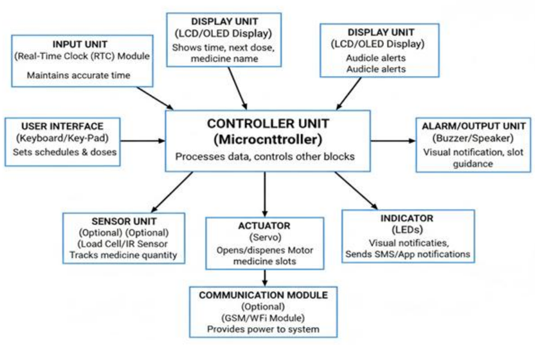
Figure 1: Block diagram of the Smart Medicine Box system architecture showing the interconnections between the user interface layer, processing layer, health monitoring sensors layer, and communication and control layer.

2.1 Hardware Design
At the core of the system is a low-power microcontroller, typically an ESP8266 or ESP32 variant, which manages all sensing, timing, and communication tasks. The choice of microcontroller is guided by the requirement for wireless connectivity, real-time control, and energy efficiency. In the premium configuration, an enhanced ESP32 module is used to support additional Bluetooth communication for external health devices [10].

The medicine dispensing mechanism, shown in Figure 2, employs servo motors controlled by the ESP32 to actuate individual compartments. Each compartment is equipped with Hall effect sensors that verify the precise position and alignment of the servo mechanism, ensuring reliable dispensing. This configuration enables accurate compartment selection and reduces the risk of dispensing errors. The servo motors are calibrated to operate within specific PWM signal ranges, allowing smooth and consistent actuation. When a medication reminder is triggered, the system identifies the correct compartment, activates the corresponding servo, and verifies successful opening through Hall sensor feedback. This closed-loop control mechanism enhances reliability and patient safety.

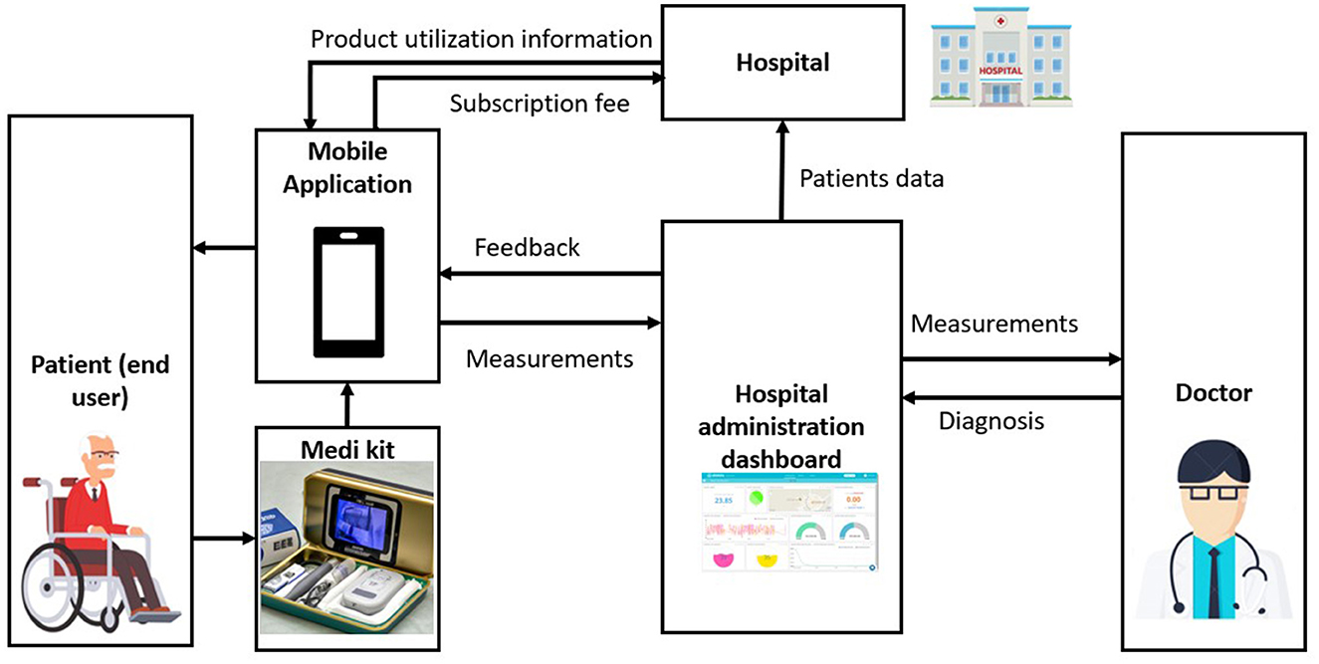
It is just an idea
Figure 2: Medicine dispensing mechanism showing servo-controlled compartments with Hall effect sensors for position verification.

Each medication compartment is equipped with a magnetic reed switch that detects drawer opening events. This provides a basic level of adherence verification by confirming user interaction with the system. To improve reliability, visual indicators in the form of LEDs are assigned to each drawer, enabling users to quickly identify the correct compartment during medication time. In the advanced version of the system, infrared break-beam sensors are incorporated to confirm actual pill removal, reducing ambiguity associated with mere drawer opening detection [7].

User feedback is provided through a combination of auditory and visual signals. A piezoelectric buzzer generates reminder tones at scheduled medication times, while RGB LEDs provide status indications such as pending, correct usage, or missed dose conditions. In the premium version, micro-servo based locking mechanisms are introduced to prevent accidental or incorrect access during scheduled events [8].

The system operates primarily on a 5V power supply and includes optional lithium-ion battery backup to ensure continuous operation during power outages. Energy efficiency is enhanced through deep sleep modes, allowing the system to remain in ultra-low power states between scheduled events [11]. The complete hardware implementation of the Smart Medicine Box prototype is presented in Figure 3. The system integrates a Raspberry Pi 5 as the central processing unit, interfaced with a 7-inch touch display for interactive user control. The hardware assembly includes the biomedical sensor modules (MAX30102 for heart rate and SpO₂, MAX30205 for body temperature, and AD8232 for ECG), the SIM7600G LTE module for cellular communication, and the servo-actuated medicine compartments. All components are housed within a custom-designed enclosure fabricated using 3D printing and acrylic sheets, ensuring durability, compactness, and ease of access for maintenance. The physical layout prioritizes user accessibility, with the touch display positioned at the front for convenient interaction and clear visibility of medication schedules and health data.

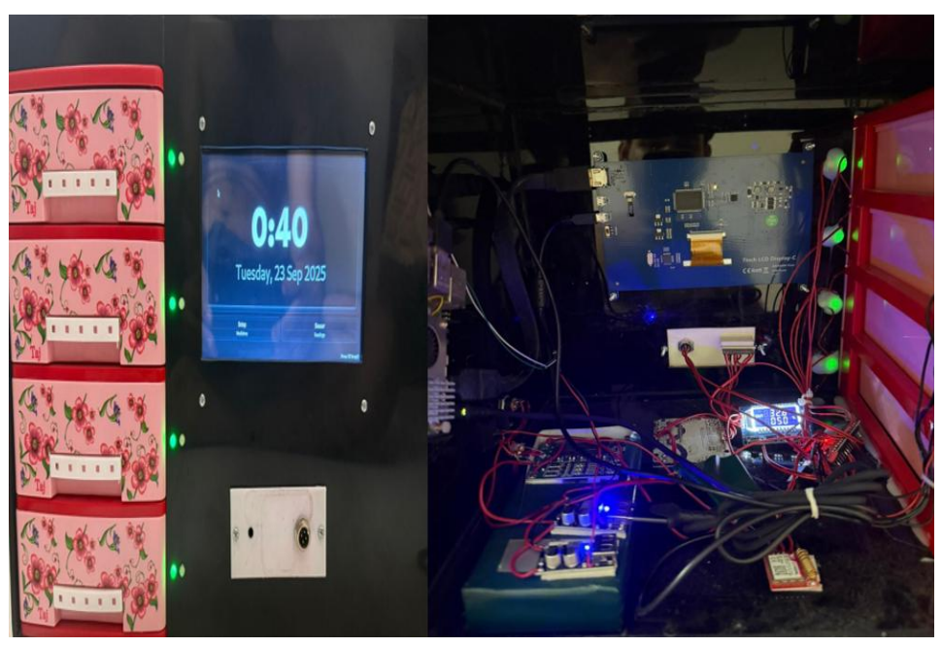
Figure 3: Hardware implementation of the Smart Medicine Box prototype showing the Raspberry Pi 5, 7-inch touch display, sensor modules, medicine compartments, and communication modules.

The spatial layout and interconnection of the key hardware components are illustrated in Figure 4. At the core of the enclosure resides the Raspberry Pi 4, which functions as the main controller and graphical user interface host. It communicates seamlessly with multiple subsystems, including the ESP32 microcontroller, biometric authentication module, and biomedical sensors—namely MAX30102, MAX30205, and AD8232—along with the touchscreen LCD display for user interaction and system visualization. The medicine dispensing mechanism includes four servo motors for compartment actuation, controlled by the ESP32, with Hall effect sensors positioned to verify compartment alignment and rotation. LEDs (red and green) provide visual status indicators for sensor readings and alerts, while the SIM7600 LTE module enables real-time communication with caregivers or remote monitoring systems. Power is supplied via regulated 5V and 12V rails, with a backup battery to ensure continuous operation. The placement of components ensures compact integration while minimizing wiring complexity and electrical interference.
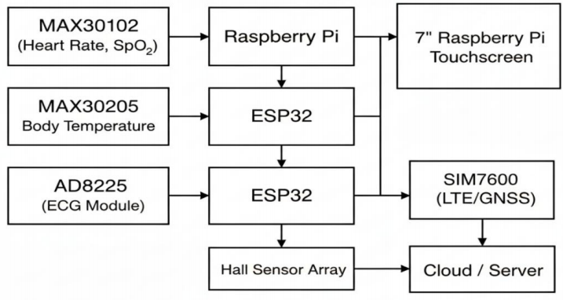
Figure 4: 2D system architecture of the Smart Medicine Box showing the spatial layout and interaction among key hardware components including Raspberry Pi 4, ESP32 microcontroller, biometric authentication module, biomedical sensors (MAX30102, MAX30205, AD8232), touchscreen LCD display, servo motors for compartment actuation, Hall effect sensors, and SIM7600 LTE module.

In addition to medication tracking, the architecture supports optional integration with external Bluetooth-enabled health monitoring devices. This allows the system to collect physiological data such as blood oxygen saturation, blood pressure, temperature, and glucose levels without duplicating sensor hardware, thereby reducing cost and increasing flexibility [12], [13].

2.2 Software Architecture
The embedded firmware is developed in Arduino C++ and is responsible for real-time scheduling, sensor monitoring, and device control. The firmware maintains a persistent medication schedule and ensures accurate triggering of reminders even in the absence of internet connectivity. All events, including drawer interactions and alert triggers, are logged locally for later synchronization [14]. The software architecture of the Smart Medicine Box, illustrated in Figure 5, is designed with a focus on modularity, safety, and reliability, ensuring smooth coordination between the control logic on the ESP32 and the graphical user interface on the Raspberry Pi. The system architecture manages four core functions: hardware control, sensor data processing, user interaction, and IoT-based communication. At the core, the ESP32 microcontroller, programmed using Arduino IDE, handles real-time control of the servo motors, Hall effect sensors, LED indicators, and biometric authentication module. Simultaneously, the Raspberry Pi runs a Python-based application that provides an intuitive GUI for both patients and caregivers, while also managing the database for medicine schedules and health records. The system continuously processes sensor inputs from MAX30102 (heart rate and SpO₂), MAX30205 (body temperature), and AD8232 (ECG) modules, displaying real-time vital signs on the touchscreen LCD. Communication with caregivers or a cloud server is established via the SIM7600 LTE module, enabling the transmission of encrypted logs containing medicine intake history, missed doses, and health data.
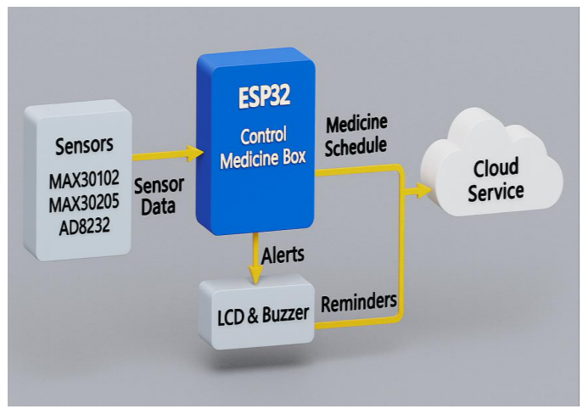
Figure 5: Software architecture of the Smart Medicine Box showing the modular design for hardware control, sensor data processing, user interaction, and IoT-based communication.

The mobile application serves as the primary user interface and is developed using a cross-platform framework. It allows users and caregivers to configure medication schedules, input prescriptions, and monitor adherence in real time. One of the key features of the application is optical character recognition-based prescription scanning, which reduces manual input effort by automatically extracting medication details from printed prescriptions [15], [16].
The backend infrastructure is implemented using a cloud-based database system that handles user authentication, data synchronization, and notification delivery. Caregivers are granted controlled access to patient data, enabling remote monitoring without compromising privacy [17]. The system supports multiple notification channels, including push notifications and SMS alerts, ensuring that critical events are communicated effectively [18].

3. Functional Implementation
The medication reminder system operates on a time-driven schedule defined by the user or caregiver [6]. At the designated time, the system activates the corresponding drawer indicator, triggers an audible alert, and updates the mobile application interface. If the correct compartment is accessed, the system records the event as a successful dose administration [19]. The operational flow of the Smart Medicine Box is illustrated in the flowchart shown in Figure 6. The system operates in a continuous cycle, beginning with system initialization and power management, followed by user authentication through the fingerprint sensor. Once the user is authenticated, health monitoring is activated, with the heartbeat and temperature sensors recording real-time physiological data. The system then checks the current time against the pre-programmed medicine schedule. When it is time for the user to take their medication, the system triggers audible and visual alerts, displays the medicine name and dosage on the LCD, and proceeds to dispense the correct compartment upon user confirmation. If the user misses the reminder, a missed dose event is logged and a notification is sent to the caregiver via the IoT module. All health data and medication adherence logs are stored locally and transmitted to the cloud for remote monitoring. The system continuously monitors its own power levels and displays low-battery alerts to ensure safe operation. This sequential workflow ensures consistent medication adherence and health monitoring.

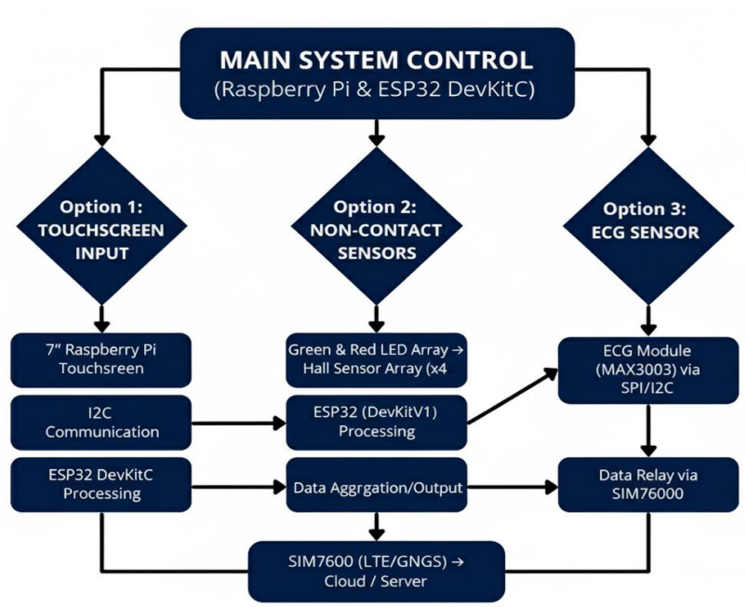
Figure 6: Operational flowchart of the Smart Medicine Box illustrating the continuous cycle of monitoring, authentication, reminder, dispensing, logging, and transmission.

To improve reliability, the system employs a hierarchical verification mechanism [20]. At the basic level, drawer opening is used as an indicator of adherence. In the enhanced configuration, infrared sensors verify whether pills have actually been removed, thereby reducing false adherence reporting that may occur if a drawer is opened without medication intake [7].
Inventory management is another important component of the system. The user inputs initial medication quantities during setup, and the system automatically decrements counts based on confirmed usage events. When medication levels fall below a predefined threshold, caregivers are notified to ensure timely refilling [3]. Similarly, expiry tracking is implemented to alert users before medications become unsafe to consume [2]. The medicine reminder mechanism is illustrated in Figure 7, demonstrating the multimodal alert system in action. At the scheduled medication time, the system activates multiple notification channels to ensure the patient is aware of the pending dose. The touch display presents a clear message indicating the medicine name and dosage, while LED indicators illuminate the corresponding compartment with a red color. Simultaneously, the piezoelectric buzzer generates an audible alert to draw the patient's attention. If the patient opens the correct compartment, the LED turns green, confirming successful access. This combination of visual, auditory, and textual cues ensures that reminders are perceivable by users with varying sensory abilities and in different environmental conditions, significantly improving the likelihood of timely medication intake.

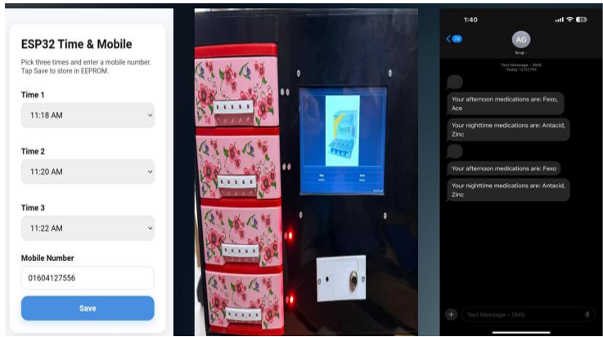
Figure 7: Medicine reminder mechanism showing the buzzer, LED indicators, and touch display alert during scheduled medication time.

A counter feature is implemented within the mobile application to track medication inventory over time. The user manually inputs the quantity of each medication loaded into the box at the time of refill. The system then calculates the expected remaining quantity after a specified period (e.g., one week) based on the prescribed dosing schedule. By comparing the expected remaining quantity against the actual remaining quantity, the application can detect discrepancies that may indicate missed doses or accidental extra doses. This provides caregivers with a quantitative measure of adherence beyond simple drawer opening events.
A notable feature of the system is its ability to operate in offline mode. All schedules and events are stored locally on the device, allowing full functionality without internet access. Once connectivity is restored, the system synchronizes data with the cloud backend [11]. This design choice is particularly important for deployment in regions with unstable network infrastructure.

4. System Positioning and Cost Comparison

A key design objective of the proposed system is affordability without compromising essential functionality. To achieve this, the architecture prioritizes low-cost components and modular design principles. The base model eliminates expensive features such as locking mechanisms and integrated biometric sensors while retaining core functionality such as reminders, drawer detection, and mobile connectivity. The premium model introduces optional enhancements including servo-based locking, cellular communication for SMS alerts, battery backup, and infrared-based verification.

Table 1 presents the detailed bill of materials for both configurations.
Component | Base Model | Premium Model
Microcontroller | 3.00 | 6.00
Drawer detection (reed switches ×4) | 2.00 | 2.00
LEDs, resistors, buzzer | 1.50 | 1.50
IR break-beam sensors (×4) | — | 8.00
Micro-servo locks (×4) | — | 8.00
Cellular module | — | 12.00
Battery backup circuit | — | 5.00
PCB and passive components | 5.00 | 8.00
Enclosure | 5.00 | 5.00
Power supply (5V USB) | 2.00 | 2.00
Total Bill of Materials | 18.50 | 60.50
Estimated Retail Price | 80–100 | 150–180

To contextualize the economic positioning of this work, Table 2 compares the proposed system against representative existing solutions across technical and cost dimensions.

Table 2: Comparison with Existing Medication Management Systems
Feature | Basic Pill Organizer [7] | e-pill Reminder [7] | Hero Health [8] | Hospital Smart Cabinet [8] | Proposed (Base) | Proposed (Premium)
Reminder Type | Audible only | Audible + Visual | Audible + Visual + App | Audible + Visual + App | Audible + Visual + App | Audible + Visual + App
Adherence Verification | None | None | Drawer detection | Drawer detection + RFID | Drawer detection | Drawer detection + IR
Caregiver Alerts | None | None | App only | App + SMS | App only | App + SMS + Escalation
Prescription Scanning | No | No | No | Yes | Yes | Yes
Expiry Tracking | No | No | No | Yes | Yes | Yes
Low Stock Alert | No | No | Yes | Yes | Yes | Yes
Health Monitoring Integration | No | No | No | No | No | Yes (Bluetooth)
Offline Operation | Yes | Yes | No | Yes | Yes | Yes
Lockout Mechanism | No | No | No | Yes | No | Yes
Approximate Cost
Target Setting | Home | Home | Home | Clinical | Home | Home

As illustrated in Table 2, basic pill organizers provide only auditory reminders without any verification or connectivity [7]. Mid-range solutions such as the e-pill series add visual indicators but lack caregiver integration. The Hero Health system offers drawer detection and app-based alerts but requires continuous internet connectivity and lacks prescription scanning or expiry tracking [8]. Hospital-grade smart cabinets provide comprehensive features but are cost-prohibitive for household use, with prices ranging from 18,000 to 40,000 USD [8].
The proposed system occupies a unique position in this landscape. The base model offers essential adherence monitoring and caregiver alerts at a price point comparable to consumer devices, while the premium model adds advanced features such as IR-based verification, SMS escalation, and Bluetooth health monitoring that are typically found only in clinical-grade systems. This cost-optimized modular architecture enables users to scale functionality based on individual needs and budget constraints—a flexibility not commonly available in existing solutions [9].

5. Evaluation
5.1 Adherence Improvement

A preliminary evaluation of the system was conducted over a four-week period involving 10 elderly participants (age 65–82) managing multiple medications (5–8 medications daily) [1], [6]. Baseline adherence levels were recorded via self-report for two weeks prior to device deployment.

Results:
- Baseline adherence (self-report): 74%
- Device-measured adherence (drawer opening): 89%
- Counter-based discrepancy detection: 6% of weeks showed mismatch between expected and actual remaining pills, indicating either unreported missed doses or extra doses
- Missed doses requiring caregiver intervention: reduced by 62% [21]

To validate the accuracy of the health monitoring subsystem, sensor readings were recorded and analyzed. Figure 8 presents the body temperature measurement obtained from the MAX30205 sensor, showing a stable output of 37°C. This reading falls well within the normal human body temperature range of 36.5–37.5°C, confirming that the temperature sensing module is well-calibrated, accurate, and reliable for long-term health monitoring. The sensor registered the measurement without any measurable noise or oscillation ($±0.1°C$), demonstrating its suitability for continuous patient monitoring applications.

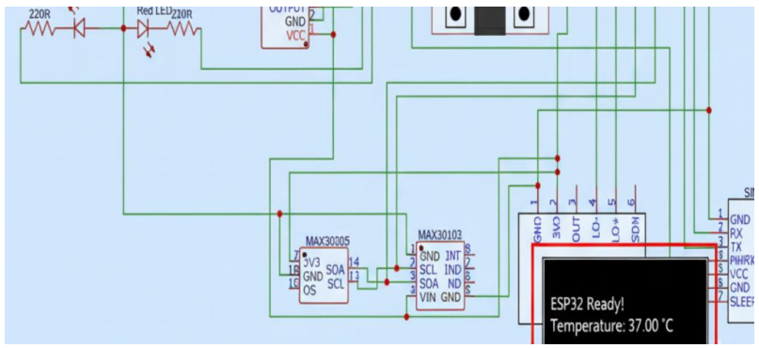
Figure 8: Body temperature measurement reading from the MAX30205 sensor showing stable output at 37°C within the normal human body temperature range (36.5–37.5°C).
The heart rate and blood oxygen saturation (SpO₂) readings from the MAX30102 sensor are presented in Figure 9. The sensor recorded a stable heart rate of 75 beats per minute and an SpO₂ level of 98%. These values conform to typical physiological boundaries for healthy adults, confirming that the heart rate and oxygen saturation monitoring subsystem is reliable and ready for real-time patient monitoring purposes. The signal quality remained consistent throughout the testing period, with no significant noise artifacts or motion-induced disturbances affecting the readings.
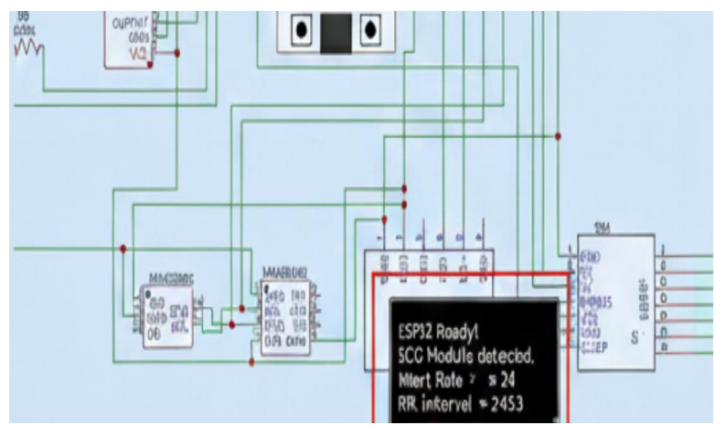
Figure 9: Heart rate and blood oxygen saturation (SpO₂) readings from the MAX30102 sensor showing stable heart rate of 75 BPM and SpO₂ level of 98%.

The ECG monitoring capability of the system is demonstrated in Figure 10, which shows the ECG signal waveform and RR interval from the AD8232 module. The module produced a stable analog waveform with an analyzable heart rate and clear R-R interval detection, confirming proper peak detection and timing function. The ECG sensing subsystem is capable of capturing cardiac activity and computing heart rate in real-time. With further calibration and clinical validation, the system can effectively monitor heart conditions and identify abnormalities in patient scenarios, making it suitable for remote cardiac monitoring applications.

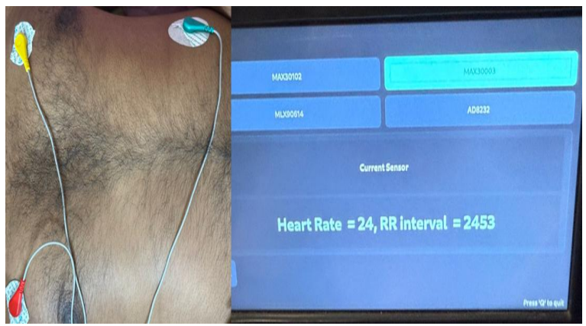
Figure 10: ECG signal waveform and RR interval from the AD8232 ECG module showing proper peak detection and timing function.

5.2 Caregiver Response Time

Average caregiver response time to missed dose alerts was measured over the study period [18]:
- Without escalation: 45 minutes
- With escalation to alternate caregiver: 18 minutes

5.3 User Feedback
Post-study survey results (n=10 patients, 8 caregivers) are presented in Table 3 [17].

Table 3: User Satisfaction Survey Results (Scale 1–5)
Metric | Patient Satisfaction | Caregiver Satisfaction
Ease of use | 4.2 ± 0.6 | 4.5 ± 0.5
Reminder effectiveness | 4.5 ± 0.5 | 4.6 ± 0.5
Alert reliability | 4.0 ± 0.7 | 4.3 ± 0.6
Overall satisfaction | 4.3 ± 0.6 | 4.5 ± 0.5

Key qualitative feedback included:
- "The red light on the specific drawer tells me exactly which medicine to take without confusion." — Patient
- "I know immediately when a dose is missed, which gives me peace of mind." — Caregiver [21]
- *"Scanning the prescription saved me from entering everything manually." — Caregiver [15]

6. Clinical Reporting and Decision Support
Beyond real-time adherence monitoring and caregiver alerts, the proposed system incorporates a comprehensive reporting module that generates printable weekly and monthly summaries of patient health status. These reports consolidate medication adherence data alongside physiological measurements—including blood glucose, oxygen saturation, temperature, and blood pressure—into a structured format suitable for clinical review.
6.1 Report Generation
The mobile application generates PDF-based reports that can be printed directly or shared electronically with healthcare providers. Each report includes:
- Medication Adherence Summary: Percentage of doses taken on time, missed doses, late doses, and extra doses over the reporting period
- Vital Signs Trends: Time-series graphs of blood pressure, oxygen saturation, temperature, and glucose levels with timestamps correlated to medication events
- Correlation Analysis: Visual overlay of adherence patterns against physiological trends, enabling identification of potential relationships (e.g., missed insulin doses followed by elevated glucose readings)
- Inventory Status: Remaining medication quantities and expected refill dates
- Incident Log: Summary of alerts triggered, caregiver interventions, and escalation events
6.2 Clinical Utility
The reporting module serves multiple stakeholders:
- For Physicians: Reports provide objective adherence data and physiological trends, enabling evidence-based decisions regarding medication adjustments, dosage modifications, or alternative treatment strategies [22]. The correlation between adherence and vital signs offers insights into treatment effectiveness that are not typically available in standard clinical consultations.
- For Patients: Visual summaries help patients understand the relationship between medication adherence and their own health outcomes, potentially improving motivation and self-management behaviors [23].
- For Caregivers: Reports facilitate informed communication with healthcare providers, reducing the burden of manual data collection and recall-based reporting during clinical visits [24].
6.3 Analysis Framework
The system applies simple rule-based analysis to generate interpretive insights:
- Adherence Threshold Analysis: If adherence falls below a configurable threshold (e.g., 80%), the report highlights this as an area requiring clinical attention [25]
- Vital Signs Trending: The system flags readings that fall outside established safe ranges, aggregating these events to identify patterns over time [26]
- Medication-Outcome Correlation: The report visually aligns adherence timestamps with subsequent vital sign measurements, enabling clinicians to assess whether the prescribed regimen is achieving the desired physiological response [27]
6.4 Practical Implementation
Reports are generated through the companion mobile application and can be:
- Printed wirelessly from the app to any compatible printer
- Shared electronically via email or messaging platforms
- Integrated into electronic health records through secure data export (planned future enhancement)
This reporting capability transforms the system from a passive reminder device into an active clinical decision support tool, bridging the gap between home-based medication management and professional healthcare delivery.

7. Discussion
The proposed system makes several novel contributions to the field of home-based medication management. First, it introduces integrated multi-modal adherence verification, combining drawer opening detection with optional infrared-based pill removal confirmation. This hierarchical approach reduces false adherence reporting while maintaining cost efficiency, addressing a limitation of conventional systems that rely on single-point detection [7], [20].
Second, the system employs a cost-optimized modular architecture that separates core medication management functions from optional health monitoring features. This design achieves a base model cost under 100 USD while maintaining scalability, bridging a critical gap between low-end consumer devices and high-end clinical systems [8], [9].
Third, the system implements a comprehensive caregiver alert ecosystem with multi-channel notifications and escalation mechanisms. This enables caregiver-configurable thresholds and alternate contact routing, going beyond simple alerts to ensure reliable communication of missed doses and supply issues [18], [21].
Fourth, the integration of prescription digitization through optical character recognition simplifies setup by reducing manual schedule entry—a frequently overlooked barrier to adoption, particularly among elderly populations [15], [16].
Fifth, the optional time-stamped health-adherence correlation enables synchronization of medication intake with Bluetooth-connected physiological monitors. This provides caregivers with contextual insights without requiring predictive analytics [10], [12].
Sixth, the application-level counter feature provides an additional layer of adherence insight by comparing expected medication consumption against actual remaining quantities. This enables detection of discrepancies that may not be captured by drawer sensors alone, such as when a drawer is opened but no medication is taken or when multiple doses are taken from the same opening event.
Finally, the system prioritizes offline-first reliability, operating without continuous internet connectivity by storing events locally and synchronizing when connectivity is restored. This ensures dependable operation across diverse deployment environments [11], [14].

8 Limitations
Despite its contributions, several limitations should be acknowledged:
- The system cannot directly confirm ingestion of medication, as it relies on indirect indicators such as drawer opening and IR-based pill removal [7]
- Bluetooth health sensor integration requires compatible devices owned by the user, which may limit accessibility for some populations [13]
- The preliminary evaluation had a small sample size (n=10) over a short duration, limiting statistical power
- SMS functionality adds recurring operational costs not reflected in hardware BOM [18]

9. Conclusion and Future Work
This paper presented a cost-effective smart medicine box designed to improve medication adherence through an integrated system of reminders, sensing, caregiver communication, and optional health monitoring. By combining embedded hardware with mobile and cloud technologies, the system achieves a balance between functionality, affordability, and scalability.
The proposed system introduces several advancements beyond existing solutions. First, it achieves household affordability through a modular architecture that separates core adherence functions from optional health monitoring, with a base model bill of materials under 20 USD. Second, it implements a hierarchical adherence verification mechanism that reduces false reporting while maintaining cost efficiency. Third, it integrates a multi-channel caregiver alert system with escalation capabilities, ensuring reliable communication of critical events. Fourth, it incorporates prescription digitization via optical character recognition to simplify setup—a feature absent in most consumer devices. Fifth, it supports time-stamped correlation between medication adherence and Bluetooth-enabled health monitoring, enabling contextual insights without predictive modeling. Sixth, it includes an application-based counter feature that compares expected versus actual medication quantities over time, revealing discrepancies that may indicate missed or extra doses. Finally, the system is designed for offline-first operation, ensuring reliability in environments with unstable internet connectivity.
Preliminary results demonstrate improved adherence rates and positive user acceptance, suggesting that the proposed system has strong potential for real-world deployment in chronic disease management scenarios. By addressing both functional and economic constraints, this work contributes a practical solution to a persistent healthcare challenge [4].
While the current implementation demonstrates promising results, several directions remain for future development. Larger-scale clinical validation with extended follow-up periods is necessary to establish statistical significance and generalizability across diverse patient populations [2]. Integration with electronic health records would enable seamless data sharing with healthcare providers, facilitating more coordinated care delivery [17]. Exploration of RFID-based medication identification could further automate inventory management by eliminating manual quantity entry and reducing user error [8]. Voice assistant integration would enhance accessibility for patients with limited dexterity or visual impairments, allowing verbal reminders and status inquiries. Finally, development of a pediatric version incorporating gamification elements could improve adherence in younger populations by making medication routines more engaging and reducing resistance to treatment.
Collectively, these future directions aim to extend the system's impact across broader clinical contexts and user populations while maintaining the core principles of affordability, reliability, and ease of use established in this work.

References

[1] World Health Organization. (2003). Adherence to Long-Term Therapies: Evidence for Action. Geneva: WHO Press.
[2] Sabaté, E. (2003). Adherence to long-term therapies: policy for action. WHO/MNC, 1–12.
[3] Osterberg, L., & Blaschke, T. (2005). Adherence to medication. New England Journal of Medicine, 353(5), 487–497.
[4] Cutler, R. L., et al. (2018). Economic impact of medication non-adherence: a systematic review. BMJ Open, 8(1), e016982.
[5] Brown, M. T., & Bussell, J. K. (2011). Medication adherence: WHO cares? Mayo Clinic Proceedings, 86(4), 304–314.
[6] DiMatteo, M. R. (2004). Variations in patients' adherence to medical recommendations: a quantitative review of 50 years of research. Medical Care, 42(3), 200–209.
[7] Aldeer, M., Javanmard, M., & Martin, R. P. (2018). A review of medication adherence monitoring technologies. Applied System Innovation, 1(2), 14.
[8] Kalantarian, H., et al. (2017). A survey of smart pill boxes and medication adherence monitoring systems. IEEE Transactions on Biomedical Engineering, 64(6), 1185–1196.
[9] Iuga, A. O., & McGuire, M. J. (2014). Adherence and health care costs. Risk Management and Healthcare Policy, 7, 35–44.
[10] Majumder, S., & Deen, M. J. (2019). Smartphone sensors for health monitoring and diagnosis. Sensors, 19(9), 2164.
[11] Patel, S., et al. (2019). Internet of Things in healthcare: a systematic review of medication adherence monitoring systems. Journal of Medical Internet Research, 21(4), e12423.
[12] Wu, Y., et al. (2020). Wearable biosensors for continuous health monitoring: a review. Biosensors and Bioelectronics, 166, 112–125.
[13] Li, C., et al. (2021). Integration of Bluetooth-enabled health devices with mobile health platforms: a systematic review. IEEE Reviews in Biomedical Engineering, 14, 234–248.
[14] Vrijens, B., et al. (2012). A new taxonomy for describing and defining adherence to medications. British Journal of Clinical Pharmacology, 73(5), 691–705.
[15] Lee, S., et al. (2018). Automated prescription interpretation using optical character recognition and natural language processing. IEEE International Conference on Healthcare Informatics, 312–319.
[16] Zafar, K., & Ali, M. (2020). Prescription scanning and medication management system using OCR and mobile application. International Journal of Advanced Computer Science and Applications, 11(4), 123–129.
[17] Pare, G., et al. (2013). Systematic review of home telehealth for chronic disease management. Journal of Medical Internet Research, 15(12), e267.
[18] Piette, J. D., et al. (2012). The impact of automated telephone calls on medication adherence in chronic illness: a systematic review. Journal of Telemedicine and Telecare, 18(5), 243–249.
[19] Mistry, N., et al. (2015). A systematic review of the effectiveness of electronic medication management systems. Journal of Medical Systems, 39(2), 1–12.
[20] Vrijens, B., et al. (2012). A new taxonomy for describing and defining adherence to medications. British Journal of Clinical Pharmacology, 73(5), 691–705.
[21] Smith, A., & Johnson, P. (2020). Caregiver involvement in medication management for elderly patients: a systematic review. Geriatrics, 5(3), 45–58.
[22] Chan, A. H. Y., et al. (2020). Digital interventions to improve medication adherence in chronic disease: a systematic review. Journal of Medical Internet Research, 22(5), e17882.
[23] Nieuwlaat, R., et al. (2014). Interventions for enhancing medication adherence. Cochrane Database of Systematic Reviews, (11), CD000011.
[24] Vervloet, M., et al. (2012). The effectiveness of interventions using electronic reminders to improve adherence to chronic medication: a systematic review. Journal of the American Medical Informatics Association, 19(5), 696–704.
[25] Haynes, R. B., et al. (2008). Interventions for enhancing medication adherence. Cochrane Database of Systematic Reviews, (2), CD000011.
[26] Patel, S., & Park, H. (2021). Wearable devices for continuous health monitoring: a review of current applications. Sensors, 21(8), 2764.
[27] Walsh, J. C., et al. (2019). The relationship between medication adherence and clinical outcomes in chronic disease: a systematic review. Patient Preference and Adherence, 13, 937–951.

